Super Grader Installation and User Guide

Overview 1

Installing Super Grader 1

Calculate grade 2

Configure the grade ranges 3

Adding a grade 4

Weighted grading 5

# 

# Overview

Super Grader is a digital EZ Grader with the added functionality of weighted grading.

# Installing Super Grader

1. Select the App Store icon on your iPhone or iPad
2. Select Search
3. Type in Super Grader
4. Select the Super Grader icon shown in Figure 1
5. Select Get and enter iTunes user and password when prompted



Figure 1.

# Calculate Grade

Enter the total number of questions into the box named Total Q’s at the top of the screen, shown below in Figure 2. Next select either the missed, score or percentage wheel. This will result in the corresponding grade being calculated and displayed at the bottom of the screen alongside the percentage.

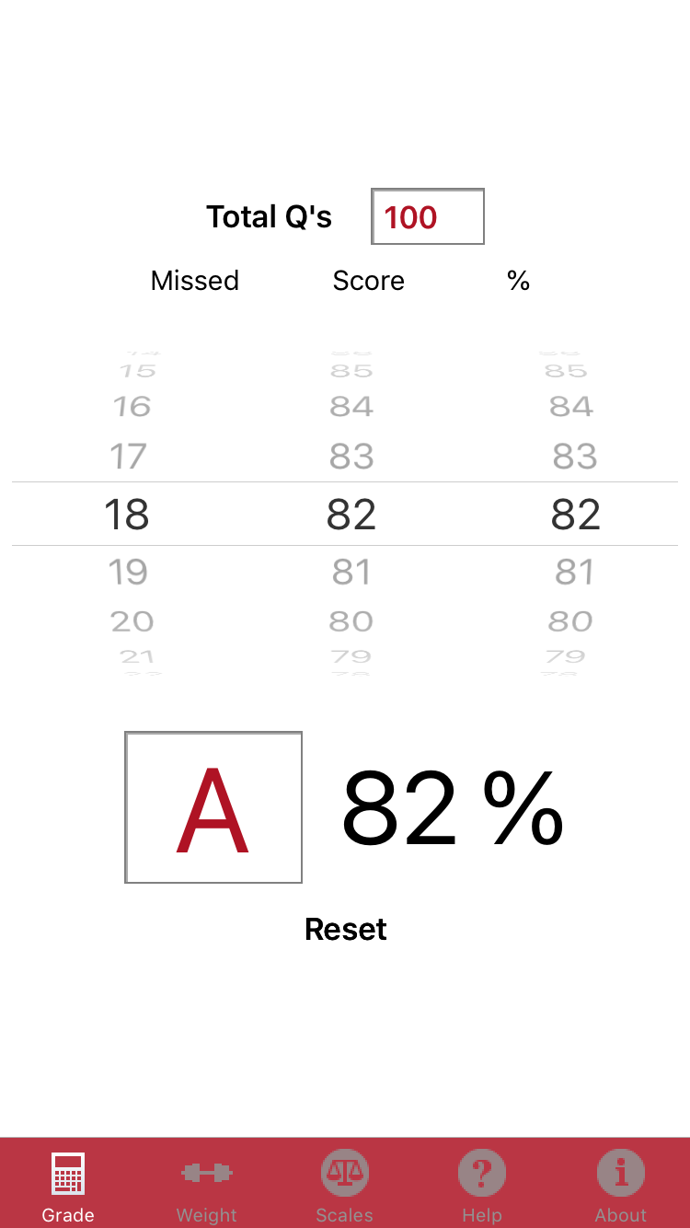

Figure 2.

# Configure the Grade Ranges

Not all schools use the same grade ranges. The default values are configured as shown below. In order to change these ranges, select the Scales tab. Next tap the edit button at the top right corner of the screen, see Figure 3.

The screen is now in edit mode. The – symbol now appears on the left of the screen alongside each grade entry.

Tap the – symbol next to the grade that is to be removed. The Delete button now appears on the right-hand side of the Grade, see Figure 4. Tap Delete and it will be removed. A minimum of one Grade range is required. If all grades are removed a message will appear to inform the user of this.

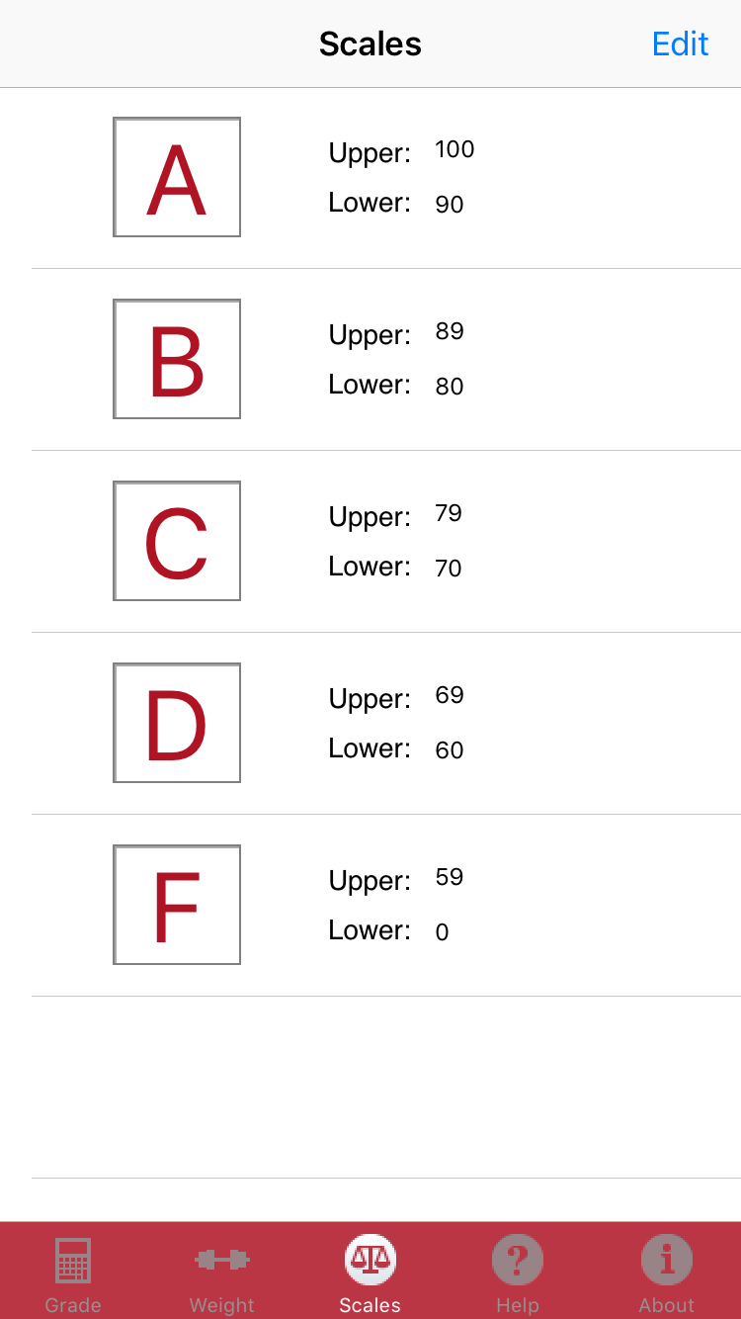 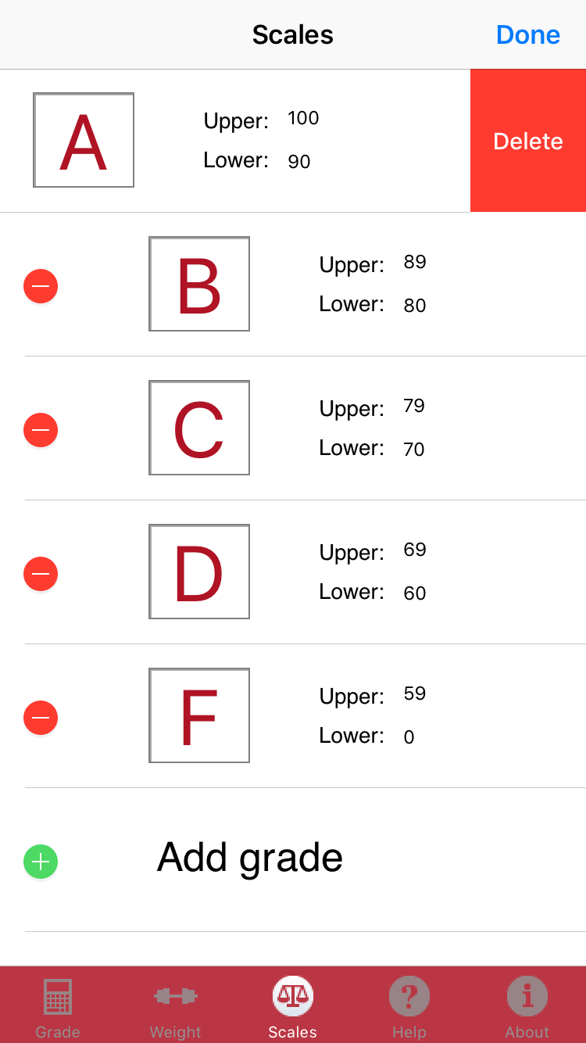

Figure 3. Figure 4.

# Adding a Grade

Tap the green + symbol to add a grade range. First enter the Grade name, followed by the Upper and Lower value. Shown in Fig 5. Finally tap the save button on the top right of the screen. The new grade will now appear, shown in Fig 6.

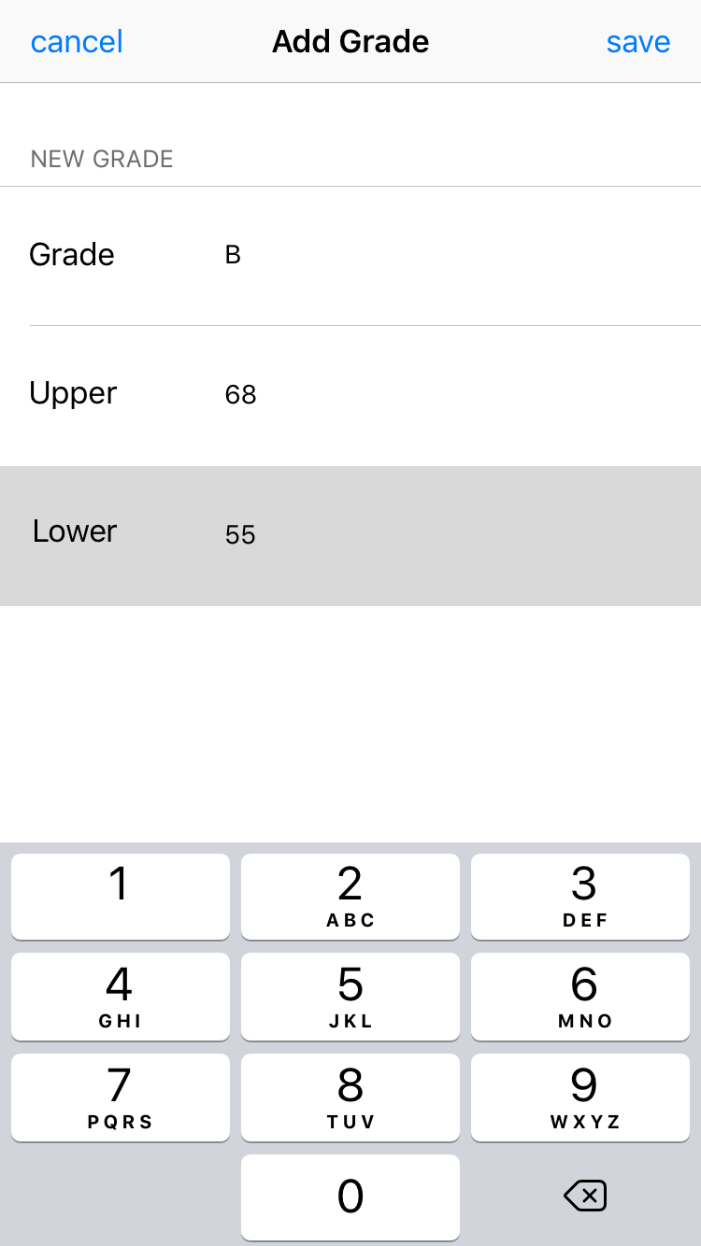 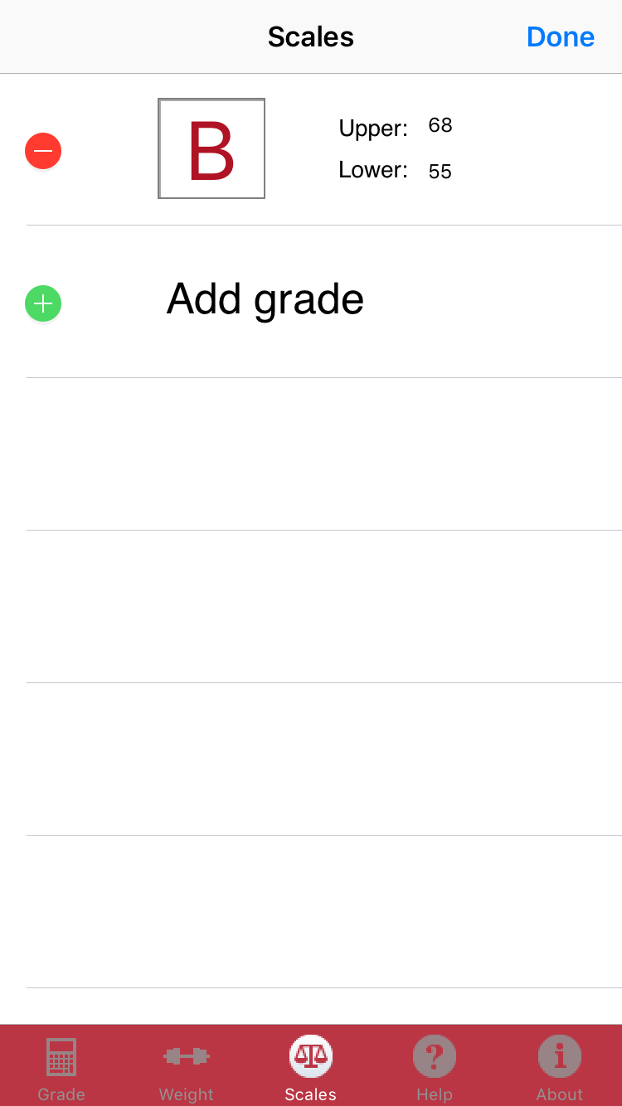

Figure 5. Figure 6.

# Weighted Grading

Super Grader supports up to 6 weighted scores. The sum of the sections percentage values cannot exceed 100. Exceeding 100 will force a reset. The running percentage total is displayed at the top of the screen.

To begin select S1 (Section 1) and scroll the percentage wheel to the required percentage. Next scroll the score wheel to the required score.

Repeat this process until the sum of the sections is equal to 100. Once this total percentage is 100 the weighted grade is displayed at the bottom of the screen alongside the final score. Fig 7 shows an example of the weighted grade screen.

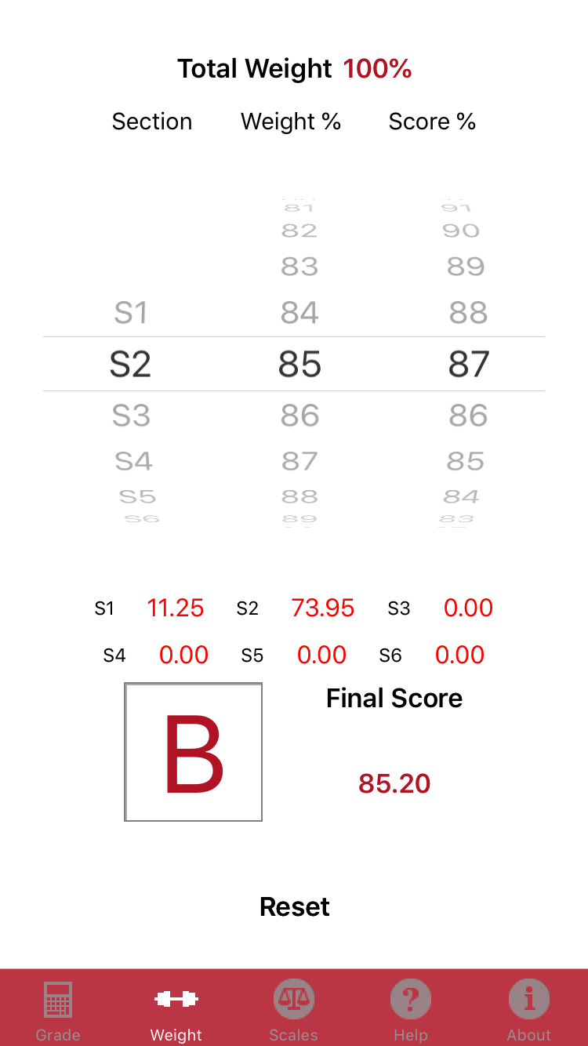

Figure 7.